BI Developer Competition Task

Task 1 a/b: Standardisation completed using PowerBI.

Screenshots:

Property Median Dataset

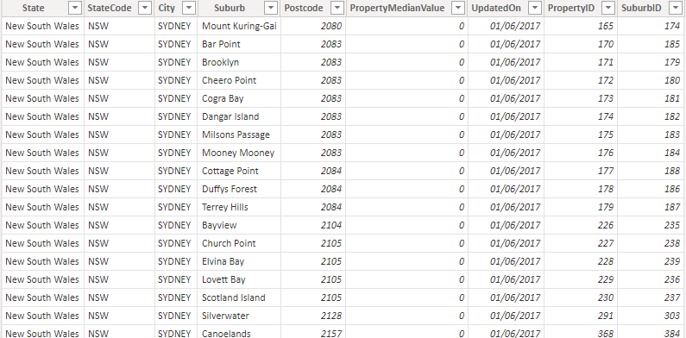

School Dataset

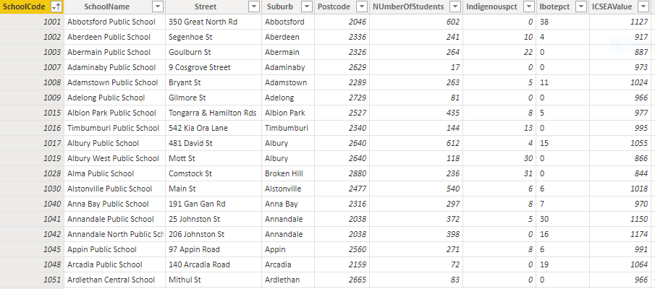

Station Entrance Dataset

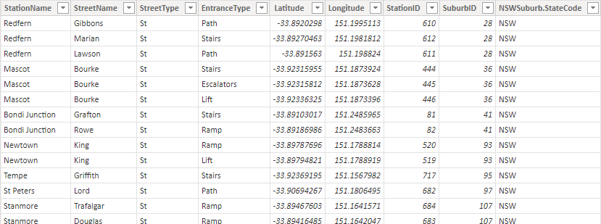

Suburb Dataset:

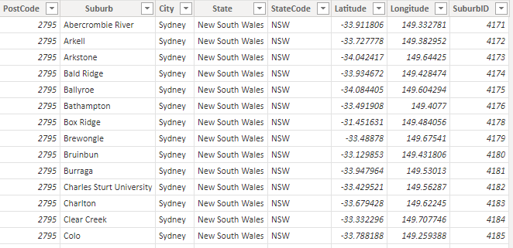

Task 1 c: DWH design:

